MEANING OF ECONOMICS:
Economics is the social science that analyzes the production, distribution, and consumption of goods and services.
- Economics can be defined as- “Economics is the social science which studies human activities and how society maximizes the satisfaction with the promotion of welfare and economic growth by efficient use of limited or scarce resources which have alternative uses.”
Nature of Economics:
In order to answer this question, it is essential to know what science is and what art is.
Science refers to a systemized body of knowledge which collects facts and tries to make an association between these facts which are useful for daily life and works on some laws and principles and these rules and principles are universally applicable. The following are the essentials of science –
- A systematic study of facts
- Certain rules and principles
- Rules and principles of science are based on cause and effects
- Rules and principles of science are universally applicable.
Art refers to that branch of knowledge which teaches how to do a particular act in a systematic manner or in its best.
Economics as Science
Economics is a systematised body of knowledge in which economic facts are studied and analysed in a systematic manner. Like any other science, the generalisations, theories or laws of economics trace out a causal relationship between two or more phenomena. Similarly, in economics, the law of demand tells us that other things remaining the same, a fall in price leads to extension in demand and a rise in price to contraction in demand. Here rise or fall in price is the cause and, contraction or extension is its effect. Hence economics is a science like any other science which has its own theories and laws which establish a relation between cause and effect.
Economics is also a science because its laws possess universal validity such as the law of diminishing returns, the law of diminishing marginal utility, the law of demand, Gresham’s law, etc.

ECONOMICS AS A POSITIVE SCIENCE:

A positive science may be defined as “a body of systematized knowledge concerning what is.” Economics is positive science because it does concern with “what is tax rate, growth rate, inflation rate etc.”

ECONOMICS AS A NORMATIVE SCIENCE:
Normative science studies “what ought to be.” As a normative science, economics is concerned with the evaluation of economic events from the ethical viewpoint. For example it is concerned with what should be the growth rate, tax rate, literacy rate, employment rate for the development of the nation.

Economics as an Art:
- Helpful in the solution of economic problem
- Increasing importance of applied economics
- Economic aspect of problems
- Economics as an art does not weaken its scientific aspect
Thus economics is a science in its methodology and an art in its application.

MICROECONOMICS: Microeconomics is the study of the economic actions of individuals and small groups of individuals. This includes the study of particular firms, particular households, individual prices, wages, income, individual industries and particular commodities.

SCOPE OF MICROECONOMICS
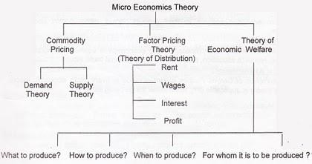

Importance / Advantages of Microeconomics:

  - Individual Behaviour Analysis
  - Resource Allocation
  - Price Mechanization
  - Helps in Economic Policy formulation
  - Free Enterprise Economy
  - Helpful in Public Finance management
  - Helpful in Foreign Trade
  - Social Welfare

MACROECONOMICS: Macroeconomics is that branch of economic theory which deals with the study of the economy in the aggregates with specific focus on unemployment, inflation, unemployment, business cycles, growth, monetary and physical policies.

Definition:

In the words of Boulding. “Macroeconomics deals not with individual quantities such as, but with aggregate of these quantities, not with individual income but with national income, not with the individual output but with national output.”

In the words of Shapiro. “Macroeconomics deals with the functioning of the economy as awhole.”

Scope of Macroeconomics:
- Theory of National Income
- Theory of Employments
- Theory of Money
- Theory of General Price Level
- Theory of Economic Growth
- Theory of International Trade
- Macro Theory of Distribution
- Theory of Trade Cycles

DISTINCTION BETWEEN MICROECONOMICS AND MACROECONOMICS

Microeconomics | Macroeconomics
1. It is that branch of economics which deals with the economic decision-making of individual economic agents such as the producer, the consumer, etc.  2. It takes into account small components of the whole economy.  3. It deals with the process of price determination in case of individual products and factors of production.  4. It is known as price theory (since it explains the process of allocation of economic resources along alternative lines of production on the basis of relative prices of various goods and services.)  5. It is concerned with the optimisation goals of individual consumers and producers (e.g., individual consumers are utility-maximisers, while individual producers are profitmaximisers.)  6. It studies the flow of economic resources or factors of production from any individual owner of such resources to any individual user of these resources, etc.  7. Microeconomic theories help us in formulating appropriate policies for resource allocation at the firm level.  8. It takes into account the aggregates over homogeneous or similar products (e.g., the supply of steel in an economy.) | 1. It is that branch of economics which deals with aggregates and averages of the entire economy, e.g., aggregate output, national income, aggregate savings and investment, etc.  2. It takes into consideration the economy of any country as a whole.  3. It deals with general price-level in any economy.  4. It is also known as the income theory (since it explains the changing levels of national income in any economy during any particular time period.)  5. It is concerned with the optimisation of the growth process of the entire economy.  6. It studies the circular flow of income and expenditure between different sectors of the economy (say, between the firm sector and the household sector.)  7. Macroeconomic theories help us in formulating appropriate policies for controlling inflation (i.e., rising price-level), unemployment, etc.  8. It takes into account the aggregates over heterogeneous or dissimilar products (say, the Gross Domestic Product of any country during any year.)
Relationship between Science, Engineering, Technology And Economics

Engineering is the discipline, art, skill and profession of acquiring and applying scientific, mathematical, economic, social, and practical knowledge, in order to design and build structures, machines, devices, systems, materials and processes that safely realize improvements to the lives of people.
Technology is the branch of knowledge that deals with the creation and use of technical means and their interrelation with life, society, and the environment.
The application of scientific knowledge for practical purposes, especially for industries and society: "computer technology"; "recycling technologies".
Engineering

Engineering is the discipline, art, skill and profession of acquiring and applying scientific, mathematical, economic, social, and practical knowledge, in order to design and build structures, machines, devices, systems, materials and processes that safely realize improvements to the lives of people.
According to the Accreditation Board for Engineering and Technology (ABET): “Engineering is the discipline in which a knowledge of the mathematical and natural sciences gained by study, experience, and practice is applied with judgment to develop ways to utilize economically the materials and forces of nature for the benefit of mankind.”
What Is Technology?
Technology is the making, usage and knowledge of tools, techniques, crafts, systems or methods of organization in order to solve a problem or serve some purpose. The term can either be applied generally or to specific areas: examples include construction technology, medical technology, and information technology.
Role of Science, Engineering and Technology in Development of Economy

There is a great reliance on technology to solve environmental problems and economic development around the world today. Science, Engineering and Technology play an important role in economic development by:
- Development of new product.
- Development of new market.
- Mechanization of the production process
- Increasing productivity.
- Changing proportion of factors.
- Development of infrastructure
- Increasing urbanization.

Managerial Economics
Managerial economics can be defined as the application of economic theory and methodology to business decision-making practice. More specifically, managerial economics is the use of tools and techniques of economic analysis to solve the problems of decision-making by the business firms which aim at achieving certain objectives subject to some constraints.
According to McNair and Meriam, “managerial economics consists of the use of economic models of thought to analyse business situations”.

Scope and Applications of Managerial Economics:
The scope of managerial economics is not yet clearly laid out because it is a developing science. Even then the following fields may be said to generally fall under Managerial Economics:
1. Demand Analysis and Forecasting
2. Cost and Production Analysis
3. Pricing Decisions, Policies and Practices
4. Profit Management
5. Capital Management
1. Demand Analysis and Forecasting: A business firm is an economic organisation which is engaged in transforming productive resources into goods that are to be sold in the market. A major part of managerial decision making depends on accurate estimates of demand. A forecast of future sales serves as a guide to management for preparing production schedules and employing resources. It will help management to maintain or strengthen its market position and profit base. Demand analysis also identifies a number of other factors influencing the demand for a product. Demand analysis and forecasting occupies a strategic place in Managerial Economics.
2. Cost and production analysis: A firm’s profitability depends much on its cost of production. A wise manager would prepare cost estimates of a range of output, identify the factors causing are cause variations in cost estimates and choose the cost-minimizing output level, taking also into consideration the degree of uncertainty in production and cost calculations. Production processes are under the charge of engineers but the business manager is supposed to carry out the production function analysis in order to avoid wastages of materials and time. Sound pricing practices depend much on cost control. The main topics discussed under cost and production analysis are: Cost concepts, cost-output relationships, Economics and Diseconomies of scale and cost control.
3. Pricing decisions, policies and practices: Pricing is a very important area of Managerial Economics. In fact, price is the genesis of the revenue of a firm ad as such the success of a business firm largely depends on the correctness of the price decisions taken by it. The important aspects dealt with this area are: Price determination in various market forms, pricing methods, differential pricing, product-line pricing and price forecasting.
4. Profit management: Business firms are generally organized for earning profit and in the long period, it is profit which provides the chief measure of success of a firm. Economics tells us that profits are the reward for uncertainty bearing and risk taking. A successful business manager is one who can form more or less correct estimates of costs and revenues likely to accrue to the firm at different levels of output. The more successful a manager is in reducing uncertainty, the higher are the profits earned by him. In fact, profit-planning and profit measurement constitute the most challenging area of Managerial Economics.
5. Capital management: The problems relating to firm’s capital investments are perhaps the most complex and troublesome. Capital management implies planning and control of capital expenditure because it involves a large sum and moreover the problems in disposing the capital assets off are so complex that they require considerable time and labour. The main topics dealt with under capital management are cost of capital, rate of return and selection of projects.

DEMAND ANALYSIS
Meaning: In common usage, demand means a desire or a want but in economics, Desire, want and demand are three different concepts.
1. Demand is an effective desire: a desire becomes an effective desire only when it is supported by following three factors;-
1. Desire for a commodity and the availability of desired commodity
2. Ability to pay
3. Willingness to pay

Prof. Mill suggests- “Demand of a commodity is the quantity of it that a consumer is ready to purchase at a given price.” Thus, demand can be defined as an effective desire of a commodity which is expressed with reference to a particular time and a particular price.
- Demand is an effective desire for a commodity that buyers are willing to purchase at given prices for a given period.
Determinants of Demand/Factors affecting Demand
- Price of the commodity: The price of a commodity affects the demand of that commodity. If price raises demand decreases and when price decreases, demand increases.
- Change in people’s income: More the people earn the more they will spend and thus the demand will rise. A fall in income will see a fall in demand.
- Change in fashion and taste: Commodities or which the fashion is out are less in demand as compared to commodities which are in fashion. In the same way, change in taste of people affects the demand of a commodity.
- Change in prices of Substitute goods: Substitute goods or services are those which can replace the want of another good or service. For example margarine is a substitute for butter. Thus a rise in butter prices will see a rise in demand for margarine and vice versa.
- Change in price of Complementary goods: Complementary goods or services are demanded along with other goods and services or jointly demanded with other goods or services. Demand for cars is affected the change in price of petrol. Same way, demand for DVD players will rise if the prices of DVDs’ fall.
- Consumer’s Expectations: if consumer expects higher income in future, he spends more at present and thereby the demand for the goods increase and opposite will be the case if he expects lower income in future. Further, if the consumer expects future prices of the goods to increase, he would rather like to buy the commodity now than later. This will increase the demand for the commodity in present. Opposite holds when it is expected that prices in future will come down.
- Changes in population: An increase in population will result in a rise in demand and vice versa.
- Quality of Product: If quality of product is good, demand of the product will be more and vice versa.

Government Policy: Economic policy adopted by the government also influences the demand for commodities. If the government imposes taxes on various commodities in the form of sales tax, excise duties, octroi etc., the price of these commodities will increase. As a result, the demand of such commodities is very likely to fall.
- Advertisement: In this age of advertisement demand for many fashionable items are created by advertising agents through T.V., newspapers, radios etc.
- Credit policy: if government credit policy is liberal, it will increase the demand and vice versa.
- Interest Rates: If interest rates are low, demand will be high and vice versa.
The different types of demand –
- Price Demand- shows relationship between price and quantity demanded. it shows inverse relationship between price of commodity and quantity demanded.
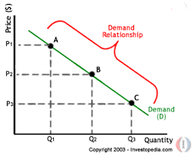
- Income demand- shows relationship between income and quantity demanded. In case of normal goods demand curve is positive because if income increases demand for these goods also increases and in case of inferior goods demand curve is negative if income increases demand for these goods decreases.
- Cross Demand- shows the relationship between quantity demanded and the price of related goods. Goods are related in two ways: Substitute Goods and Complimentary Goods. Substitute Goods are those goods which can be replaced by each other e.g. tea and coffee, shirt and t-shirt. Complimentary Goods are those goods which are used together e.g. petrol and car, ink and pen, shoes and socks. In case of substitute goods demand curve will be positive and in case of complimentary goods demand curve will be negative.
- Direct and Derived Demand- Direct demand refers to demand for goods meant for final consumption; it is the demand for consumers’ goods like food items, readymade garments and houses. By contrast, derived demand refers to demand for goods which are needed for further production; it is the demand for producers’ goods like industrial raw materials, machine tools and equipments.
- Demand for Consumer goods and Demand for Consumer goods- goods purchased for consumption are known as Demand for Consumer goods i.e. demand for clothes; milk, bread etc. and goods purchased for production purpose are known as Demand for Capital goods i.e. demand for raw material, tools and machinery etc.
- Collective demand: demand for the products which have multiple uses. When price of these product increases, people start to make the limited use of these products and when price of these products decrease, people start multiple uses of them.
LAW OF DEMAND: The law of demand states that other factors being constant, price and quantity demand of any good and service are inversely related to each other. When the price of a product increases, the demand for the same product will fall and vice versa.
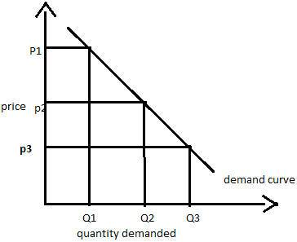

The above diagram shows the demand curve which is downward sloping. Clearly when the price of the commodity increases from price p3 to p2, then its quantity demand comes down from Q3 to Q2 and then to Q3 and vice versa.
Assumptions of the law of demand: the law is based on the following assumptions-
- There should be no change in the income of consumer.
- No change in taste & preference of consumer.
- No change in the prices of the related goods.
- No change in the size of population.
- Distribution of income & wealth should be equal.
- The goods under question should be normal one.
- There should be perfect competition in the market.
Reasons of Demand Curve Sloping Downward to the right:
- Law of diminishing marginal utility: this law explains as consumer keep continue to consume any product, the utility of that product decreases, he can purchase extra quantity at lower price, and this is why demand curve is downward sloping.
- Substitution effect: If consumers don't see a meaningful difference between products, they'll buy the one with the lowest price, so a price increase will drive them toward substitutes, while a reduction will draw them in.
- Income effect: When prices drop (or rise), people can buy more (or less) of a good for the same amount of money because of increase (decrease) in real income
- Change in number of consumers: when price of any commodity decreases, number of consumers of that product increases because those who were not consuming in the past, now they will also start to consume it because of lower price.
- Diverse use of a commodity: some products have multiple uses. When price of these product increases, people start to make the limited use of these products and when price of these products decrease, people start multiple uses of them.

Exceptions to the Law of Demand
Basic Necessities or Highly Essential Good:
In case of basic naecessaties like salt, milk, sugar andcertain highly essential items such as life- saving drugs, people buy a fixed quantity at all possible price. Heart patients will buy the same quantity of ‘Sorbitrate’ whether price is high or low. Their response to price change is almost nil.
Possibility of Future Rise in Prices:
If a consumer anticipates that the price of a commodity will rise in future he will purchase more of that commodity now. The consumer will purchase more even if current price is high.
Snob Appeal or Veblen Goods or prestigious goods:
People sometimes buy certain commodities like diamonds at high prices not due to their intrinsic worth but for a different reason. The basic object is to display their riches to the other members of the community to which they themselves belong.
This is known as ‘snob appeal’, which induces people to purchase items of conspicuous consumption. Such a commodity is also known as Veblen good (named after the economist Thorstein Veblen) whose demand rises (fails) when its price rises (falls).
Inferior goods/ Giffen goods:
Some special varieties of inferior goods are termed as giffen goods. Cheaper varieties of goods like low priced rice, low priced bread, etc. are some examples of Giffen goods. Law of demand is not applicable as the demand for such items.

Change in income
The demand for goods and services is also affected by change in income of the consumers. If the consumers’ income increases, they will demand more goods or services even at a higher price. On the other hand, they will demand less quantity of goods or services even at lower price if there is decrease in their income. It is against the law of demand.
Elasticity of Demand
Meaning of Elasticity of Demand: Elasticity of demand (Ed) is defined as the percentage change in the quantity demanded caused by one percent change in the demand determinant under consideration (like price of product, income of consumers, price of related goods, advertisement etc.) while other determinants are held constant.
The general equation for the measurement of elasticity of demand is :
E = Percentage (Proportionate) change in demand of goods X
Percentage (Proportionate) change in determinant Z
Various types of elasticity of demand are as follows-
- Price elasticity of demand
- Income elasticity of demand
- Cross elasticity of demand

- Price Elasticity of Demand: Price elasticity of demand is a measure of proportionate change in the quantity demanded due to proportionate change in price of that commodity. Thus, the responsiveness of demand to changes in price is called Price elasticity of demand. It is calculated as follows-
Ep = (-) Proportionate change in Demand of product X
Proportionate change in Price of product X
Formula - Ep = (rQd/rP) × (P/Qd)
Where rQd= change in demand ( new demand – old demand)
rP = change in price of product itself (new price-old price)
P = old/original price
D = old/original demand

Kinds/Types (Degrees) Of Price Elasticity of Demand
- Perfectly Elastic- when demand of a product changes- increases or decreases even when there is no change in price, it is known as perfect elastic demand. Ep∞
- Highly Elastic- % change in demand is higher than % change in the price of that commodity. Ep>1
- Unit Elasticity- % change in demand is equal to % change in the price of that commodity. Ep= 1
- Inelastic- % change in demand is less than % change in the price of that commodity. Ep<1
- Perfectly Inelastic- no change in demand due to changes in the prices. Here, Ep=0
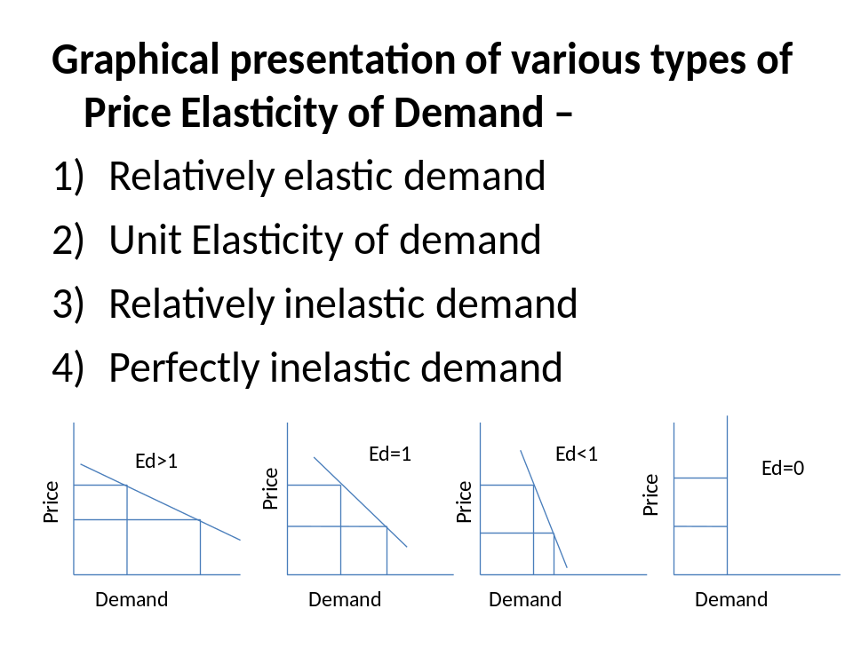
Price

- Income Elasticity Of Demand: In economics, the income elasticity of demand measures the responsiveness of the quantity demanded of a good to the change in the income of the people demanding the good. It means the ratio of percentage change in quantity demanded to the percentage change in income of consumer.

Ey = Proportionate change in Demand of product X
Proportionate change in Income of consumer
Symbolically -
- Ey = (rQ/rY) × (Y/Q)
Here , ∆Q = Change in the quantity demanded.
Q = Original (old)quantity demanded.
∆y = Change in income.
Y = Original (old) income.

- For example ,when Income of the consumer = 2,500/- , he purchases 20 units of X, when income = 3,000/- he purchases 25 units of X.
Thus, Ey = (rQ/rY) × (Y/Q)
Ey = (5/500) x (2500/20)
= 1.25
Therefore here the Ey is 1.25 which is more than one
3.Cross elasticity of demand: In economics, the cross elasticity of demand measures the responsiveness of the quantity demand of a good to a change in the price of another good. It is measured as the percentage change in quantity demanded for the first good that occurs in response to a percentage change in price of the second good i.e. related goods. For example, if, in response to a 10% increase in the price of fuel, the quantity of new cars that are fuel inefficient demanded decreased by 20%, the cross elasticity of demand would be -20%/10% = -
Ec= %change in quantity demanded of good X
% change in price of good Y
If the Ec is zero, it means the two goods are not related to each other. If Ec is positive then two goods are substitutes and being negative Ec means the goods are complementary goods.
Methods to measure elasticity of demand
Elasticity of demand is the degree of change in amount demanded of a commodity in response to a change in price. Price elasticity of demand can be measured through three popular methods. These methods are:
1. Percentage method or Arithmetic method
2. Total Expenditure method
3. Graphic method or point method.
1. Percentage method:-
The Percentage Method- given by Flux. According to this method price elasticity is estimated by dividing the percentage change in amount demanded by the percentage change in price of the commodity. Thus given the percentage change of both amount demanded and price we can derive elasticity of demand. If the percentage charge in amount demanded is greater that the percentage change in price, the coefficient thus derived will be greater than one.

- e_{p} = (ΔQ/ΔP) × (P/Q)
- It is also known as ratio method, when we measure the ratio as: e_{p} = %ΔQ/%ΔP
- Where, %ΔQ = percentage change in demand
%ΔP = percentage change in price.
If percentage change in amount demanded is less than percentage change in price, the elasticity is said to be less than one. But if percentage change of both amount demanded and price is same, elasticity of demand is said to be unit.
2. Total expenditure method
Marshall suggested that the simplest way to decide whether demand is elastic or inelastic is to examine the change in total outlay of the consumer or total revenue of the firm.
Total Revenue = (Price × Quantity Sold)
TR = (P × Q)
Marshall has laid down the following propositions:
(a) Elastic Demand: If e_{p} > 1, the percentage rise in quantity demanded is greater than the percentage fall in price. Revenue increases because the increase in quantity demanded more than offsets the decrease in price. Price and revenue move in opposite directions.
(b) Inelastic Demand: If e_{p} < 1, the percentage rise in quantity demanded is less than the percentage fall in price. Revenue falls because the decline in price is not offset by the relatively small rise in quantity. Price and revenue move in the same direction.
(c) Unitary Elastic Demand: If e_{p} = 1, the percentage rise in quantity demanded equals the percentage fall in price. Revenue is unchanged because the decline in price is just offset by the rise in quantity.
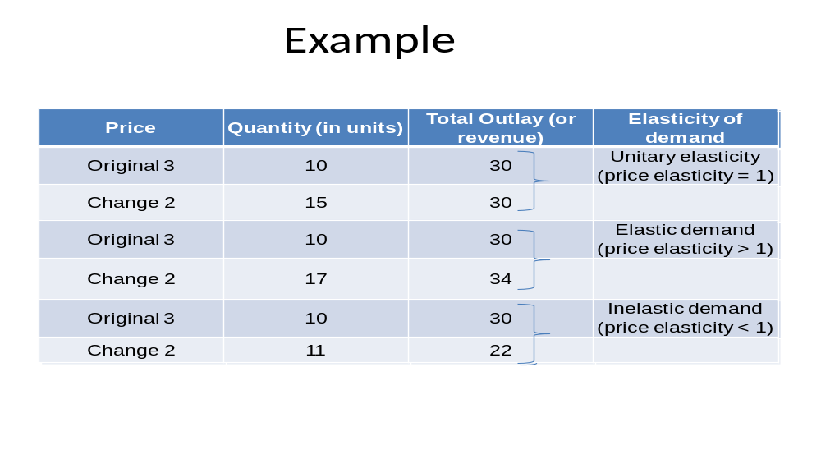
3. Graphic method:
Graphic method is otherwise known as point method or Geometric method. According to this method elasticity of demand is measured on different points on a straight line demand curve. The price elasticity of demand at a point on a straight line is equal to the lower segment of the demand curve divided by upper segment of the demand curve.
Thus at mid point on a straight-line demand curve, elasticity will be equal to unity; at higher points on the same demand curve, but to the left of the mid-point, elasticity will be greater than unity, at lower points on the demand curve, but to the right of the midpoint, elasticity will be less than unity.

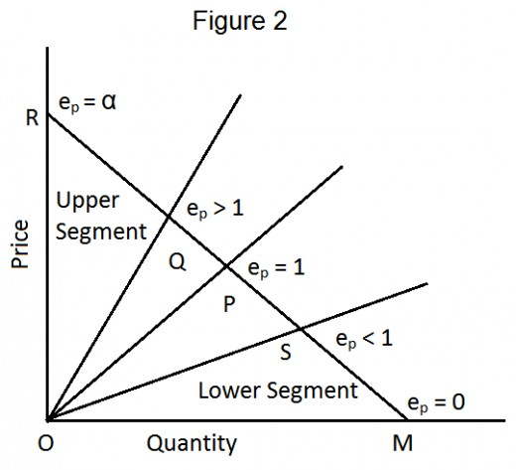
Movements along Demand Curve vs. Shift of Demand Curve
The basic difference between a move along a demand curve and a shifting in the curve is that the former is caused by a change in price while the latter is not. A move along the curve results in a different quantity demanded at a different price. A shifting in demand curve means that demand is changing because of other factors. It means different quantity will be demanded at a given price because due to change in income, family size, taste etc.
Increase and decrease in demand represent shift of the demand curve to right or left resulting from changes in factors such as income, tastes, prices of other goods etc whereas Expansion and contraction represent movement upwards or downwards on the same curve resulting from a change in price of the commodity.
Diagram-
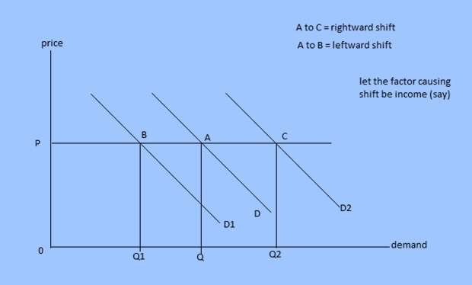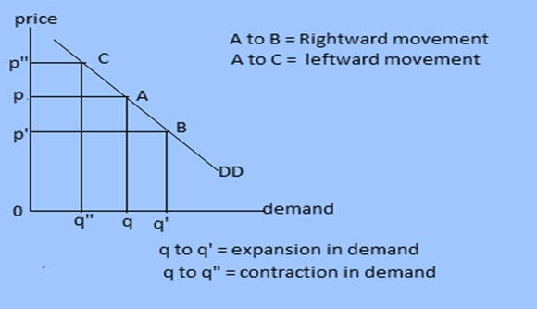

Determinants of Elasticity of Demand
Apart from the price, there are several other factors that influence the elasticity of demand. These are:
- Consumer Income: The income of the consumer also affects the elasticity of demand. For high-income groups, the demand is said to be less elastic as the rise or fall in the price will not have much effect on the demand for a product. Whereas, in case of the low-income groups, the demand is said to be elastic and rise and fall in the price have a significant effect on the quantity demanded. Such as when the price falls the demand increases and vice-versa.
- Amount of Money Spent: The elasticity of demand for a product is determined by the proportion of income spent by the individual on that product. In case of certain goods, such as matchbox, salt a consumer spends a very small amount of his income, let’s say Rs 2, then even if their prices rise the demand for these products will not be affected to a great extent. Thus, the demand for such products is said to be inelastic.
Whereas foods and clothing are the items where an individual spends a major proportion of his income and therefore, if there is any change in the price of these items, the demand will get affected.
- Nature of Commodity: The elasticity of demand also depends on the nature of the commodity. The product can be categorized as luxury, convenience, necessary goods. The demand for the necessities of life, such as food and clothing is inelastic as their demand cannot be postponed. The demand for the Comfort Goods is neither elastic nor inelastic. As with the rise and fall in their prices, the demand decreases or increases moderately.
Whereas the demand for the luxury goods is said to be highly elastic because even with a slight change in its price the demand changes significantly. But, however, the demand for the prestige goods is said to be inelastic, because people are ready to buy these commodities at any price, such as antiques, gems, stones, etc.
- Several Uses of Commodity: The elasticity of demand also depends on the number of uses of the commodity. Such as, if the commodity is used for a single purpose, then the change in the price will affect the demand for commodity only in that use, and thus the demand for that commodity is said to be inelastic. Whereas, if the product has several uses, such as raw material coal, iron, steel, etc., then the change in their price will affect the demand for these commodities in its many uses. Thus, the demand for such products is said to be elastic.
- Whether the Demand can be Postponed or not: If the demand for a particular product cannot be postponed then, the demand is said to be inelastic. Such as, Wheat is required in daily life and hence its demand cannot be postponed. On the other hand, the items whose demand can be postponed is said to have elastic demand. Such as the demand for the furniture can be postponed until the time its prices fall.
- Existence of Substitutes: The substitutes are the goods which can be used in place of one another. The goods which have close substitutes are said to have elastic demand. Such as, tea and coffee are close substitutes and if the price of tea increases, then people will switch to the coffee and demand for the tea will decrease significantly. Whereas, if there are no close substitutes for a product, then its demand is said to be inelastic. Such as salt and sugar do not have their close substitutes and hence lower is their price elasticity.
- Joint Demand: The elasticity of demand also depends on the complementary goods, the goods which are used jointly. Such as car and petrol, pen and ink, etc. Here the elasticity of demand of secondary (supporting) commodity depends on the elasticity of demand of the major commodity. Such as, if the demand for pen is inelastic, then the demand for the ink will also be less elastic.
- Range of Prices: The price range in which the commodities lie also affects the elasticity of demand. Such as the higher range products are usually bought by the rich people, and they do not care much about the change in the price and hence the demand for such higher range commodities is said to be inelastic.
Also, the lower range commodities have inelastic demand because these are already low priced and can be bought by any sections of the society. But the commodities in middle range prices are said to have an elastic demand because with the fall in the prices the middle class and the lower middle class are induced to buy that commodity and therefore the demand increases. But however, if the prices are increased the consumption reduces and as a result demand falls.
Thus, these are some of the important determinants of elasticity of demand that every firm should understand properly before deciding on the price of their offerings.

Importance and uses of Elasticity of Demand

Price Determination: The elasticity of demand for a product is the basis of its price determination. The ratio in which the demand for a product will fall with the rise in its price and vice versa can be known with the knowledge of elasticity of demand.
If the demand for a product is inelastic, the producer can charge high price for it, whereas for an elastic demand product he will charge low price. Thus, the knowledge of elasticity of demand is essential for management in order to earn maximum profit.

Price Discrimination by Monopolist: Under monopoly discrimination the problem of pricing the same commodity in two different markets also depends on the elasticity of demand in each market. In the market with elastic demand for his commodity, the discriminating monopolist fixes a low price and in the market with less elastic demand, he charges a high price.

Price Determination of Factors of Production: Price elasticity of demand helps in determining price to be paid to the factors of production. Share of each factor in the national product is determined in proportion to its demand in the productive activity. If demand for a particular factor is inelastic as compared to the other factors, then it will attract more rewards. In other words, if the demand of a factor is inelastic, its price will be high and if it is elastic, its price will be low.

Determination of sale policy for supper markets: Super Markets is a market where in a variety of goods are sold by a single organization. These items are generally of mass consumption.
Therefore, the organization is supposed to sell commodities at lower prices than charged by shopkeepers in the other bazars.
Thus, the policy adopted is to charge a slightly lower price for items whose demand is relatively elastic and the costs are covered by increased sales.

Output decisions: The elasticity of demand helps the businessman to decide about production. A businessman chooses the optimum product- mix on the basis of elasticity of demand for various products. The products having more elastic demand are preferred by the businessmen. The sale of such products can be increased with a little reduction in their prices.
From the above discussion it is amply clear that price elasticity of demand is of great significance in making business decisions. Determination of Gains from International Trade: In order to fix prices of the goods to be exported, it is important to have knowledge about the elasticity’s of demand for such goods. A country may fix higher prices for the products with inelastic demand. However, if demand for such goods in the importing country is elastic, then the exporting country will have to fix lower prices.

Formulation of Government Policies: The concept of price elasticity of demand is important for formulating government policies, especially the taxation policy. Government can impose higher taxes on goods with inelastic demand, whereas, low rates of taxes are imposed on commodities with elastic demand.

Importance in international trade:
The concept of elasticity of demand is of crucial importance in many aspects of international trade.
The success of the policy of devaluation to correct the adverse balance of payment depends upon the elasticity of demand for exports and imports of the country.
The policy of devaluation would be beneficial when demand for exports and imports is price-elastic.
A country will benefit from international trade when: (i) it fixes lower price for exports items whose demand is price elastic and high price for those exports whose demand is inelastic (ii) the demand for imports should be inelastic for a fall in price and inelastic for arise in price.
The terms of trade between the two countries also depends upon the elasticity of demand of exports and imports of two countries. If the demand is inelastic, the terms of trade will be in favour of the seller country.

Explanation of paradox of poverty: Exceptionally good harvest brings poverty to the farmers and this situation is called ‘Paradox of Poverty’.
This paradox is easily explained by the inelastic nature of demand for most farm products. Since the demand is inelastic, prices of farm products fall sharply as a result of large increase in their supply in the year of bumper crops. Due to sharp fall in prices, the farmers get less income even by selling larger quantity.
This paradox of poverty is the basis of regulation and control of farm products prices. Government fixes the minimum prices of farm products because the demand for farm products is inelastic. Thus, the concept of elasticity of demand helps the government in determining its agricultural policies.

